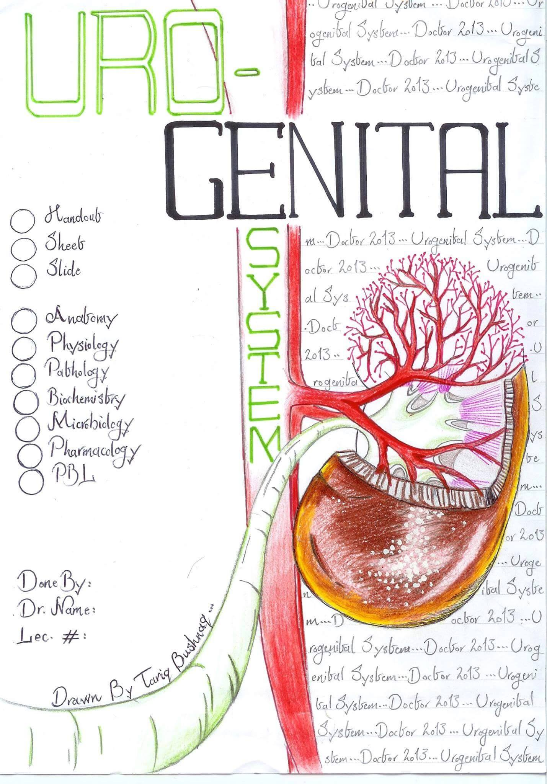
EbraheemAlabdali
2
Saleemkhresha

Male genital physiology

Control of sebaceous glands
- Growth and secretion activity of the sebaceous glands of the face, back and chest are controlled by androgens, (primarily Dihydrotestosterone) and inhibited by estrogen.
Increase sensitivity to androgens especially during puberty is the cause of Acne Vulgaris in both males and females.
The Doctor shows a picture of a sperm and explains its parts:
Head: Contains the nucleus that contains 22 somatic chromosomes and 1 sex chromosome either X or Y.
In front of the head, there is Acrosome which contains enzymes that lyse the tissue around the ovum, it is important for functioning.
Mid Piece: It contains Mitochondria which is important for energy.
Note : nowadays there are specific tests on mitochondria to specify the parent ,how? The doctor don't knows
Tail: Important for movement.
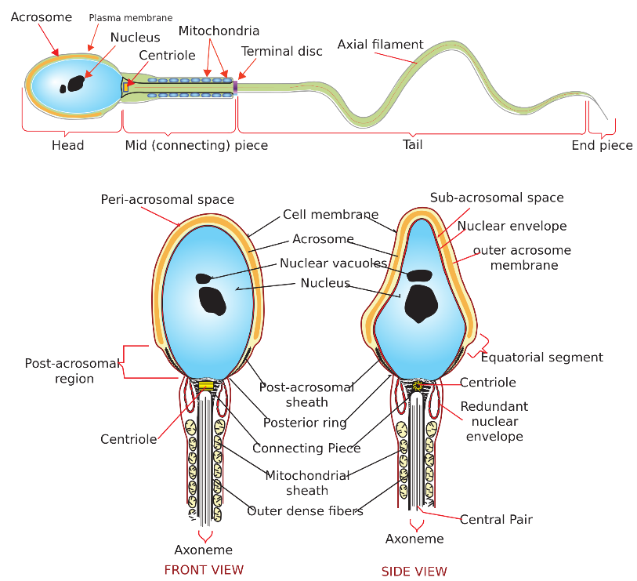

Enzymes of the Acrosome:
There are many enzymes in the acrosome, the most important being the Hyaluronidase and acrosin. These enzymes are not activated or released unless the sperm get in contact with an ovum. All the sperms in contact with ovum are activated and release the enzymes to lyse the tissue around the ovum.
Delayed puberty:
-Puberty in males occur between age 13 and 14. By puberty we mean the beginning of sperm formation.
- Delayed puberty can be either normal variant (Familial or racial) or due to serious illness like typhus and tuberculosis, psychological stress, hypogonadism and hyperprolactinaemia (From last lecture).
-Impotence and infertility.
Impotence: Inability to achieve a maintained erection.
Infertility (sterility): Inability of the sperm to fertilize the ovum.
Sterility is not impotence but impotence is sterility.
Causes of impotence:
1) Psychological disturbances. (Most common).
2) Drugs.
3) Autonomic neuropathy as in diabetes.
4) hyperprolacteniemia, hypogonadism.
5) Vascular abnormalities and major heart surgeries
6) Leriche Syndrome (Aortoiliac atherosclerosis)
How does Viagra (Sildenafil) Work?
Nitric oxide activates Guanylyl cyclase forming cGMP from GTP that will result in closure of calcium channels and smooth muscle relaxation and erection. 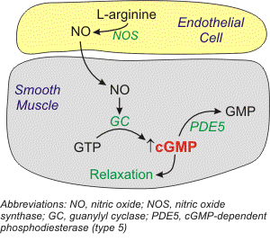
Phosphodiesterase 5 (PDE5) enzyme inhibits cGMP and destroys it.
Sildenafil (Viagra) inhibits PDE5 which prolongs the effect of cGMP.
70% of users of Sildenafil are below 40 years old.
Viagra was first used to treat hypertension but they noticed it worked against impotence.
Viagra induced erection doesn’t occur until the male is stimulated.
Precautions: Any one with serious illness has to be careful.
It is contraindicated in patients who are taking nitrates and in major heart disease.
It should not be taken with other antihypertensive drugs, especially ACEI.
Dosage and Frequency depends on age. High dose may result in hypotension and death.
Viagra shouldn't be taken more than 3 times a week regardless of the age.

Composition of Semen.
10% sperms, Fluids containing enzymes, elements, chemicals.
60% from seminal vesicle, 20% from prostate.
Prostate doesn’t affect sexual function and fertility.
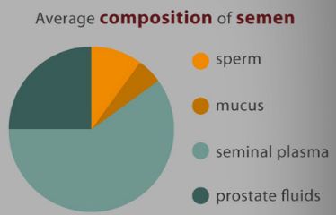
The secretions of accessory glands prolong survival and fertility.
Hyaluronidaseis not produced from the accessory glands and it is found originally in the sperm acrosome .
When the semen is ejaculated, it coagulates to prevent the loss of the semen.
To examine the causes of reproductive dysfunction you have to do history, physical exam and semen analysis.
Components of semen analysis.
Volume: 3-4 ml
Count: 100 million in each ml. (300-400 million per ejaculation)
Motility: normal 60-70% of sperms are motile. (not all the sperms are motile )
Morphology: 60 to 70% have normal shape.
When the semen is ejaculated, it coagulates (similar to the blood )to prevent the loss of the semen and then it has to be liquefied within 30 minutes to free the sperm to the fertilize the ovum.

Abnormalities of sperm morphology:
- sperm with two heads
- sperm with two tails
- sperm with very small head
- many others
Abnormalities of the sperm count:
Oligospermia (Low sperms), Azoospermia (No sperms)
Percentage of the sperms reaching the fertilization site is 0.001%
They have to reach within 60 minutes or else they will lose their chance.

