Quiz on proteins

-this quiz contains questions about proteins that have an idea similar to the questions that come in the exam
-the source of the questions are from many websites and some of them are from my ideas I hope everyone benefits from them
___________________________________________________________

1-The portion of the protein that has the least mobility is :-
A) Alpha helix
B) Beta sheet
C) peptide bond
D) side chain

2-one of the following amino acid segments of polypeptides can't form continuous alpha helix :
A) Leu-Gly-Tyr-His
B) Phe-Ala-Ser-Cys
C) Met-Gly-Thr-Gln
D) His-Lys-Arg-Leu

3- The parts of amino acids involved in peptide bond formation :
A) The carboxylix group of one amino acid and the side chain of the other
B) The carboxylic group of one amino acid and the amino group of the other
C) The amino group of both amino acids
D) the carboxylic group of both amino acids

4-polypeptides have a zigzag structure because :
A) it's most stable
B) the peptide bond is rigid
C)The Phi and Psi bonds in the amino acid are rotatable
D) all of the above

5-Phenylketonuria is a disease characterized by a deficiency in Phenylalanine hydroxylase enzyme which is responsible for :
A) Hydroxylation of Phe to Tyrosin
B) Hydroxylation of Phe to threonine
C) accumulation of Phenylalanine in blood
D) A+C

6- One of the following amino acids must be taken from diet :-A)Tyrosin
B) Glycine
C) isoleucine
D) Serine

7-Which of the following terms are used to describe amino acid chains in proteins :
A) Dipeptide
B) Oligopeptide
C) Polypeptide
D) All of the above

8- In Gel electrophoresis the following segment of polypeptide is the fastest toward the anoid :
A) Gly-Ser-Thr-Leu
B) Lys-Arg-Gly-His
C) Asp-Gly-Gln-Val
D) Glu-Ala-Asp-Ser
9-one of the following amino acids has 2 chirality centers:-
A) theronine B ) leucine C) Valine D) Tyrosin

10-Myoglobin is :
A- primary structure protein
B- Secondary structure protein
C-Tertiary structure protein
D-Quaternary structure protein

11- Which one of the following is alpha helix terminator :
A) proline
B) Cysteine
C)Methionine
D) Glycine

12-in a highly basic solution (pH=13) the dominant form of glycine is :
A) NH2-CH2-COO-
B)NH3+ -CH2-COO-
C) NH3+ -CH2-COOH
D) NH2 -CH2-COOH

13-one of the following is a characteristic of distal histidine in myoglobin:
A) it prevents the perpendicular binding of O2
B) it's covalently bonded to iron atom in the heme to stabilize it in the hydrophobic pocket of myoglobin
C) found in the exterior of myoglobin protein
D) A+C

14-when the pH of glutamic acid solution is more than 4.1 one of the following is true :
A) the molecule would be in the zwitterionic form
B) the net charge of the molecule is -1
C) the net charge of the molecule is 0
D) A+C

15-one of the following is wrong about denaturation :-
A ) misfolding of proteins
B) caused by breaking of peptide bonds between amino acid residues
C ) caused by breaking non-covalent attractions between the R-groups of amino acids
D) blood acidosis leads to denaturation of some enzymes in the body

16-the biological activity of proteins is determined by it's :
A ) peptide bonds
B) amino acid sequence
C) ability to form alpha helix
D) ability to form Beta sheet

17- the most abundant amino acid in collagen is :-
A ) Proline
B) Glycine
C) Valine
D) Lysine

18 – one of the following is true about turns :-
A ) it usually has proline
B ) it's a type of super secondary structure
C ) it has irregular structure
D) it contains up to 20 amino acids

19- one of the following is wrong about elasitin :-
A ) it requires the activity of Hydroxylysine for cross linking
B ) it is rich in hydrophobic amino acids
C ) it is presented in blood vessels
D) when lysyl oxidize enzyme is denaturated elastin will be affected

20- one of the following is not one of the characteristic of Hemoglobin :
A ) it contains 2 different types of subunits
B ) it contains a prosthetic group
C ) it is an allosteric protein
D ) none of the above

21-Vitamin C prevents scurvy by :-
A ) it's involved in the formation of Beta- pleated sheet of collagen
B ) it is used as a cofactor for hydroxyproline enzyme in the primary structure of collagen
C ) it's involved in metabolism of Heme used in hemoglobin
D ) it encourage the formation of disulfide linkages in collagen

22-the structure of myoglobin consist of :
A ) almost entirely of Beta-sheet
B ) Mixture of Alpha helix and beta sheet
C ) almost entirely of alpha helix
D ) super secondary motif structure

23- Hemoglobin is an allosteric protein because :
A ) it has more than one subunit
B ) binding of O2 to one subunit will increase the affinity of other subunits
C ) binding of O2 to one subunit will change the hydrophobic interactions between other subunits
D) all of the above

24- about Prion disease one of the following is wrong :-
A ) it is contagious
B ) triggers the formation of Amyloids of prion protein in brain tissue
C ) it can't be inherited
D ) it is a Protein misfolding disease

25- in Histidine amino acid the total charge of the molecule at a pH more than 9 is :
A ) – 1 B) 0 C) +1 D) +2

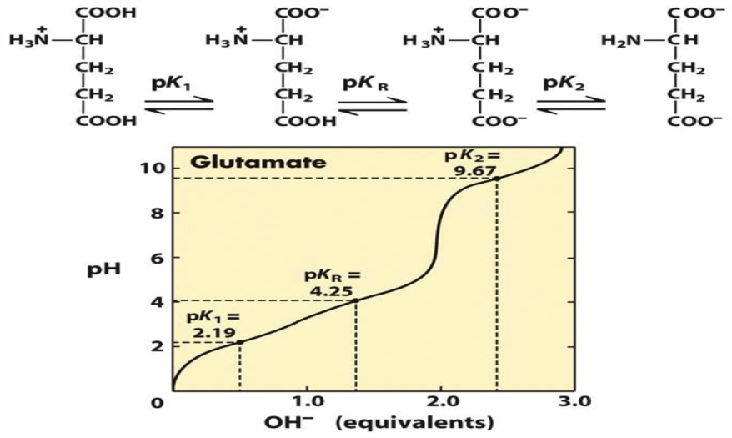
26- the Isoelectric point of Glutamic acid in the following titration curve is :-
A ) 6.96
B) 3.22
C ) 4.25
D) 5.93

27- one of the following is a difference between turns and loops :-
A ) turns are used to connect secondary structures unlike loops
B ) loops are smaller than turns
C ) loops have regular structure unlike turns that have irregular ones
D ) Turns are smaller than loops

28 – about domains one of the following is wrong :-
A ) they give us an indication about protein folding and has nothing to do with biological activity
B ) they are super secondary structures
C ) leucine zipper is an example of a domain
D ) They are larger than motifs
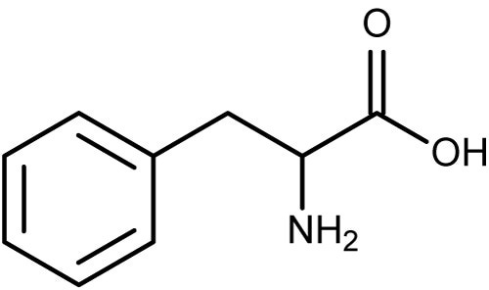
29- this structure belongs to one of the following amino acids :-
A ) Tyr B) Phe C ) Thr D) His
30 – one of the following amino acids can exist in the cis configuration when forming a polypeptide :-
A ) Glycine B) Lysine C) Tyrosin D) Proline

Answers :-
10. C | 9. A | 8. D | 7.D | 6.C | 5. A | 4. D | 3. B | 2. D | 1.C
20.D | 19.A | 18.A | 17.B | 16.B | 15.B | 14.B | 13.A | 12.A | 11.A
30. D | 29.B | 28.A | 27.D | 26.B | 25.A | 24.C | 23.D | 22.C | 21.B

