**Quiz on lipids**

1 – one of the following fatty acids is volatile at room temperature :

A – CH3(CH2)8COOH

B- CH3(CH2)3COOH

C – CH3(CH2)14COOH

D- CH3(CH2)6COOH

2- One of the followings is not produced from Arachidonic acid :-

A – testerone

B – leukotriens

C – prostacyclines

D – thrombaxane A2

3- in oleic acid synthesis ______ fatty acid will be introduced to a double bond to form oleic acid :

A – palmatoleic acid

B- lenoleic acid

C – Arachidonic acid

D – Stearic acid

4- Alpha lenolenic acid belongs to one of the following omega families :

A – omega 7

B- omega 3

C- omega 6

D- omega 9

5- CH3(CH2)12 C—O—CO—(CH2)14 CH3

This structure represent a :

A – Triglyceride

B – Palasmalogin

C – Wax

D – Glycerophospholipid

6- one of the most important reactions to break triglycerides into glycerol and 3 fatty acids in the salt form is :

A – dehydrogenation

B- Saponification

C- Phosphorylation

D – Hydrolysis

7- one of the following is wrong regarding Arachidonic acid :

A – it has 3 double bonds

B- it is an omega 6 fattyacid

C – it's designation is 20 :4

D – it used to synthesis molecules that stimulates leukocytes and platelets

8- one of the following is common in all phospholipids (including glycerophospholipids and sphingomeylines ) :

A – glycerol backbone

B- the presence of at least one fatty acid

C – the presence of phosphate group

D - B + C

9- Cerebrosides , gangliosides ,Globisides are all

A – glycoproteins

B – lipoproteins

C – glycerophospholipids

D – glycolipids

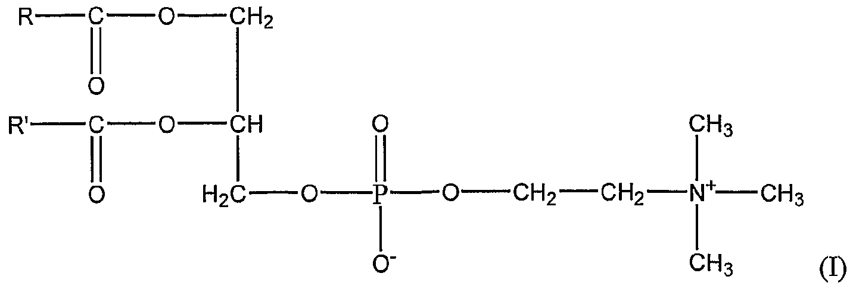10- about the following structure one of the following is wrong :

A - it's the most important membrane lipid

B – it's degraded by lecithinase enzyme

C – it has sphingosine backbone

D – it's a type of glycerophospholipd



11- the following structure is :

A – galactocerebroside

B –Glucocerebresoide

C – Sulfatides

D – sialic acid

12 – on the following lipoproteins carries the most amount of lipids :

A – Chylomicrones

B – VLDL

C-LDL

D – HDL

13- Lipoproteins can carry lipids in the blood plasma because :-

A – they are hydrophobic

B – they are hydrophilic

C – they can form micelle

D – none of the above

14- one of the following lipoproteins are known as cholesterol scavengers :-

A – LDL

B-HDL

C- VLDL

D- Chylomicrones

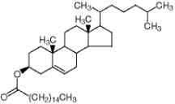15- the following structure is :

cholesterol sterate

progesterone

Vitamine D

cholesterol palmatate

16- Plasmalogines are different from other types of glycerophospholipids because :

A – one of the fatty acids attached to glycerol is unsaturated

B – one of the fatty acids is linked to glycerol by an ether linkage

C – it's precursor are dihydroxyacetone

D – all of the above

17 – one of the following lipids is located in the cytoplasmic side of the plasma membrane :-

A – Glycolipids

B- phosphatidylcholine

C- phosphotidylinositole

D – sphingomylein

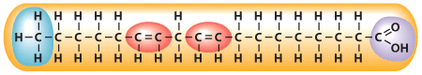18- which of the following describes the fatty acid in the diagram :

A – monounsaturated fatty acid

B- saturated fatty acid

C-trans fat

D- polyunsaturated fatty acid

19-Lipoproteins that transport cholesterol to cells are called__________ and lipoproteins that pick up cholesterol from cells are called__________.

A – VLDL , HDL

B- LDL , HDL

C- Cholymicrons , HDL

D- VLDL , LDL

20-Which of the following statements about the function of lipids in the body in false?

A – Cholesterol is used to make Vitamin D

B – Triglycerides serve as a concentrated source of energy

C – Adipose tissue provide cushion for our organs

D- all sphingolipids have phosphate group in common

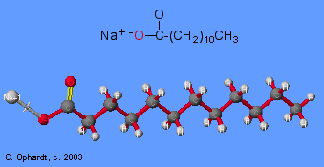

21 – the following molecule occur mainly From :

A – Hydrolysis of triglycerides

B – Saponification of triglycerides

C – dehydration of triglycerides

D – methylation of triglycerides

22- after the removal of the sugar molecule in ganglioside the molecule that remain is:-

A – ceramide

B- sphingosine

C – Glycerol

D – triglyceride

23- one of the following is true about cholecalciferol (Vitamin D3)

A – it's a steroid

B- it undergo hydroxylation in the liver and kidney

C – it's converted to biologically active form by UV-light from sunshine

D- none of the above

24- what is the feature of Vitamine E that makes it a biological antioxidant :-

A – it's hydrophobic

B – it contain a long fatty acid chain

C – it contains an aromatic ring

D – it's associated with the cell membrane

25 – the presence of cholesterol in the phopholipid bilayer of the plasma membrane helps to :-

A – prevent aggregation of fatty acid chains at low temperatures

B – prevents colliding of fatty acids chains at high temperatures

C- contributes to the decoration of the fluid mosaic model of the plasma membrane

D – all of the above

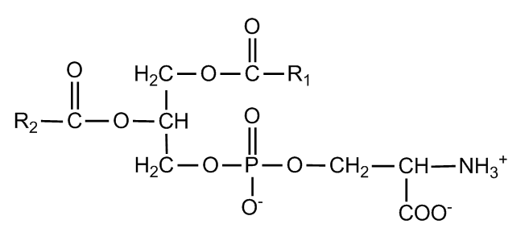26 – the following structure is :

A – phosphatydl ethanolamine

B – phosphatydlserine

C-Cerebrosides

D – phosphatydl inositol

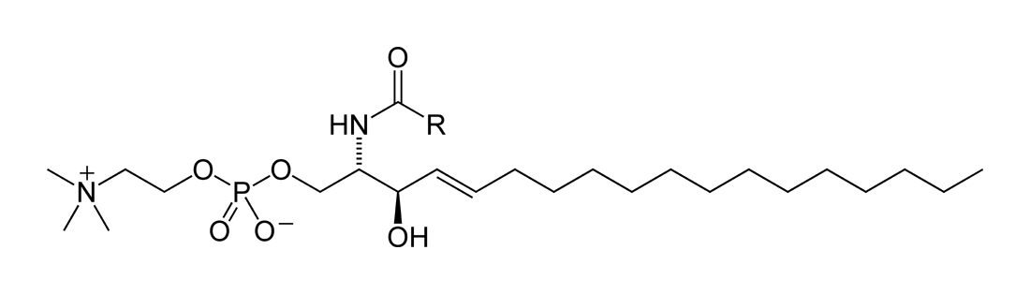27- the following structure is :

A – glycerophospholipid

B – ceramide

C - Sphingomylein

D – ganglioside

28- Aspirin helps to minimize the risks of heart attacks by :

A – reducing the synthesis of thromboxane A2

B- reducing the synthesis of archidonic acids

C – blocking cyclooxygenase enzyme

D- A+C

29- one of the following molecules is not amphipathic :-

A – phospholipids

B- Triacylglycerol

C – Cholestrol

D – free fatty acid

**Answers**

|  |  |  |  |  |  |  |  |  |  |
| --- | --- | --- | --- | --- | --- | --- | --- | --- | --- |
| **1-B** | **2-A** | **3-D** | **4-B** | **5-C** | **6-B** | **7-A** | **8-D** | **9-D** | **10-C** |
| **11-C** | **12-A** | **13-C** | **14-B** | **15-D** | **16-D** | **17-C** | **18-D** | **19-B** | **20-D** |
| **21-B** | **22-A** | **23-B** | **24-C** | **25-D** | **26-B** | **27-C** | **28-D** | **29-B** |  |

**Explanations :-**

1 – short chain fatty acids are the ones that contains 3-6 carbons and they are volatile at room temperature , soluble in water , liquid in nature

2- Archidonic acid is a fatty is used to synthesis eicosanoids (prostaglandins ,thromboxane A2 …. ) And testesteron is synthesized from steroids

3- Oleic acid is made of 18 carbons with one double bond between carbon number 9 and 10 , stearic acid is a saturated 18 carbon fatty acid , in the synthesis of oleic acid a double bond is added on carbon 9 of stearic acid to convert it to oleic acid

5- the structure is a wax because we can notice that there is an ester linkage and ester linkage is always between a fatty acid and an alcohol and because we have 1 long fatty acid and 1 long chain alcohol it's a wax

6- saponification is a process of breaking triglycerides into glycerol and 3 fatty acids in their sodium salt conformation

7- Arachidonic acid designation is 20:4 which means it's an 20 carbon fatty acid with 4 double bonds and their position is at carbon 5,8,11,14 so it's an omega 6 fatty acid

8- glycerophospholipids are composed of glycerol back bone with 2 fatty acids attached to the first 2 carbons and a phosphate group attached on the last carbon while sphingomyleins are composed of sphingosine backbone with one fatty acid attached to carbon number 2 and phosphate group on carbon number 1 , so they both have fatty acids and phosphate group in common .

11- from the structure we can see a sugar which is modified by the addition of sulfate group and that sugar is attached to sphingosine backbone so the whole structure is a glycolipid with sulfated modified sugar attached to carbon number 1 so it's a sulfatide

13- they ability of liposomes to form micelles helps them to carry lipids because lipids can dissolve in the hydrophobic interior of that mecelles and be carried within the blood stream

14 – HDL helps to transport extra cholesterol from peripheral tissue to the liver to get them out of the body that's why they are called scavengers(zbaleeen )

15- cholesterol can be modified by the replacement of the hydroxyl group with long chain fatty acid which is in this picture palmatic acid so the whole molecule would be named cholesterol palmatate

17- phosphatylinositol are on the cytoplasmic side of the plasma membrane because they serve in signal transduction to transfere signals from the outside to the inside of the cell

20 – they are 2 types of sphingolipids : sphingomyleins which has sphingosine back bone with phosphate group attached to the 1st carbon and glycolipids which have a sugar connected the 1st carbon instead of phosphate so phosphate is not common in both types

22- ceremide is the basic molecule from which all types of sphingolipids arised from it is composed of a sphingosine back bone with one fatty acid attached to it

23 – cholecalcifirols becomes functional vitamine D by hydroxylation on carbon number 1 and 25 and not from the activity of sunlight and becarefull that cholecalcifrol is not a steroid because it doesn’t have the 4 ring structure that all steroids share in common .

24**- because vitamine E fights free radicals by giving them the electron it needs , vitamin E will become a free radical itself so because of the presence of an aromatic ring which creates resonance it helps to solve this problem**