Quiz on Carbohydrates

1-Humans are unable to digest :-
A – Starch B- denaturated proteins C- glycogen D- cellulose
2-Lactose is made by linking glucose and galactose by :
A – alpha:1-4 glycosidic linkage
B- Beta: 1-4 glycosidic linkage
C- Alpha: 1-6 glycosidic linkage
D- all of the above
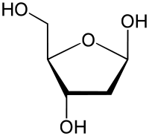
3- the following structure is :
A – N-acetyl-2-D-glucoseamine
B- deoxyribose sugar
C- deoxyglucose sugar
D- fructose sugar

4- when oxidizing glucose with a weak oxidizing agent the resulting molecule is :
A – gluconate
B- glucuronate
C- glocaric acid
D- deoxyglucose

5- one of the following sugars isn't/aren't a reducing sugar :
A – maltose
B- sucrose
C- glucose
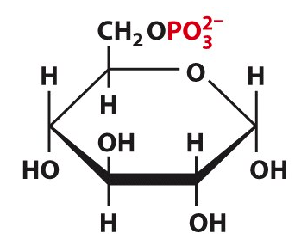
D- Lactose
6- the following structure is :
A – formed by phosphor-esterfication reaction
B- glucose-6-phosphate
C- the first compound to be formed in glycolysis of glucose
D- all of the above

7- polysaccharides are not considered reducing sugars because :-
A – they don't contain a free anomeric carbon
B- they are hydrophilic
C – the amount of free anomeric carbons is too small in compare with the whole molecule
D- none of the above

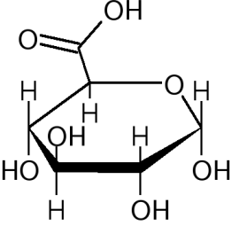
8- the following structure is :
A – galactose
B- sorbitol
C- Gluconic acid
D- Glucuronic acid

9- the number of chirality centers in an open chain 2-glucoseamine is :
A – 2
B- 1
C- 4
D- 3

10 – the structural relationship between galactose and mannose :-
A – they are epimers at carbon number 2
B – they are diasteriomers
C – they are epimers at carbon number 4
D – they are structural isomers

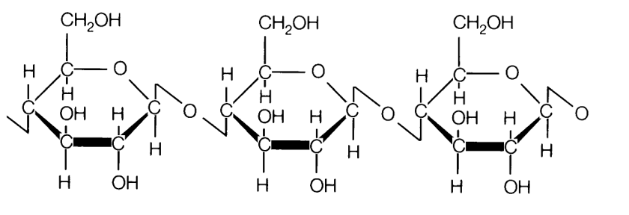
depending on the structure above which is a segment of a certain polypeptide answer the questions (11-13)
11-one of the following is true :
A – it can be raffinose sugar
B – it is a storage polysaccharides
C – it is a structural polysaccharide
D – it can be digested by our digestive system
12- the type of linkage in the structure is :-
A – alpha : 1-4
B- Beta : 1-4
C- alpha : 1-2
D – Alpha : 1-6
13- one of the following is wrong about the structure above :-
A – this structure is strengthened by hydrogen bonding
B – is a reducing sugar
C – make up plants cell wall
D – is a homopolysaccharide
14- humans can't digest fibers because :-
A – humans lack necessary enzymes
B- fibers are soluble in water
C – fibers are insoluble in water
D- Bile is ineffective on fibers
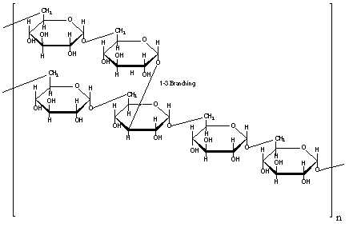
15- the wrong statement about the following structure :
A – it is branched
B- It's a storage polysaccharide
C-The glycosidic linkage at the branching points is always alpha :1-6
D- it is a homopolysaccharide

16- regarding the membrane oligosaccharide structures in various blood groups (ABO ) which statement is not correct :
A – the core structure in all people is : N-Acetyl glucoseamine –Galactose – Fucose
B- blood group A has N-acetyl galactose amine plus the core structure
C- blood group B has Galactose plus the core structure
D – blood group O has only the core structure

17- which of the following is a glycosaminoglycan :-
A – Chondriotin-6- sulfate
B- Heparan sulfate
C – dermatan sulfate
D- all of the above
18- D-glucose and D- galactose are :-
A – constituents of lactose
B – epimers
C – all of the above
D – structural isomers
19 – one of the following pairs is not an epimer :-
A – Erythrose and Therose
B – glucose and mannose
C – galactose and mannose
D – glucose and galactose

20- wrong statement regarding the structure of Various polysaccharides is :
A – Amylopectin is a branched polymer of D-alpha glucose with alpha :1-4 glycosidic linkages with alpha:1-6 branching points
B – cellulose is a branched polymer of glucose with B-1,4- linkage
C-Glycogen is more branched than starch
D – Amylose is a nonbrached polymer of D-alpha glucose with alpha: 1-4 glycosidic linkage .
21- about polysaccharides one of the following is true :-
A – the type of glycdosidic linkage in polysaccharides determines their function
B- structural polysaccharides are more flexible than storage polysaccharides
C- Raffinose is an example of polysaccharides
D- A+C
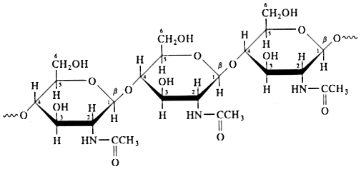
22- the correct statement about the following polysaccharide is :-
A – it is a heteropolysacchardie
B – it forms the exoskeletone of insects
C- it is made of B-D-glucose sugar monomers
D – it forms the cell wall in plants

23- Glycosidic bonds :
A. Connect sugar molecules in both linear and branches of complex carbohydrates.
B. Only connect carbon-1 of one sugar to carbon-4 of another.
C. Destroy the asymmetric character of the participating carbons
D. Only connect carbon-1 of one sugar to carbon-6 of another
E. Are not found commonly in sugars

24- Complete the statement: The furanose form of fructose is generated by formation of a hemiketal involving the attack of the hydroxyl group on carbon ____ with carbon ____
A. 2 ,5
B. 5,2
C. 2, 6
D. 6, 2
E. 1, 6

25-Blood group antigen (ABO) are _______ on the outside of a red blood cell
A-Glycoproteins that differ in the protein moiety.
B-Glycolipids that differ in the carbohydrate moiety.
C-Membrane proteins that differ in state of phosphorylation.
D-The protein moieties of a glycoproteins that are encoded by different genes.

Answers :-

1 | 2-D | 3-B | 4-A | 5-B | 6-D | 7-C | 8-D | 9-C | 10-B
11-C | 12-B | 13-B | 14-A | 15-C | 16-A | 17-D | 18-C | 19-C | 20-B
21-A | 22-B | 23-A | 24-B | 25-B |  | 1-D

