Physiology Lecture Sheet #6
Neurotransmitters

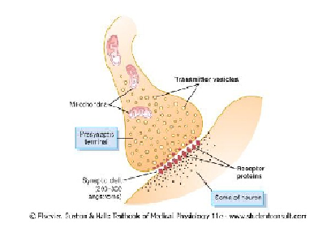
As mentioned in the previous lecture, we have two different categories of Junctions or Synpases;
- Neuromuscular Junctions – comprising of both neural and non-neural structures
- Synapses – comprising of only neural structures
These Synapses are sub-categorized into electrical synapses (gap junctions) present in the heart, and chemical synapses which are characteristically unidirectional and have no relapse / return, and are present mostly in the brain (99.9%), with 0.1% being present in the olfactory system.
Both of these Neuromuscular Junctions & Synapses work in coordination to help carry out all of the functions of the body.
---------------------------
Synapses are much more difficult to study in comparison to Neuromuscular Junctions due to the fact that they may contain 2 or sometimes 3 different neurotransmitters in a single terminal; each of which either activate or inhibit neurons. Synapses are also difficult to obtain in experiments.
Some of these neurotransmitters work for short periods of time, while others work for long periods of time; and collectively these are named the Neuro-modulators, which change your attitude and behaviour towards different things in life.
The human brain contains 150 chemical substances called neurotransmitters; 50 of which are well known to all physicians and researchers, and when these chemical substances are present in abnormal concentrations in the brain (whether they are higher or lower than normal), this can be a manifestation which physicians utilize in order to identify and diagnose different mental diseases.
Generally, Neurotransmitters are subdivided into two major categories;
- Small particles / molecules – rapidly acting neurotransmitters
- Large particles / molecules – slowly acting neurotransmitters
Small particles sit on their highly specific receptors, open or close a channel and make an effect – similar to those of the neuromuscular junctions.
However these neurotransmitters are not as important in comparison to the other type of neurotransmitters – the large particles / molecules, which modulate your behaviour and personality.

*Please read and MEMORISE the table concerning the 7 major differences between small and large particles in the slides provided by the Doctor*

So what do we mean by long acting / long lasting neurotransmitters?
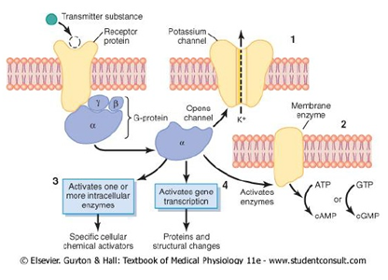
When a neurotransmitter is released and is attached to its highly specific receptor, we from the Neuromuscular Junction that the next step is to open or close a channel. However, in the brain, when this neurotransmitter-receptor complex is formed, a G-protein is activated, a protein molecule that is found inside the neuron.
These G-proteins have different parts including Alpha, Beta, Gamma...etc.
The Alpha particle will subsequently detach from the G-protein and will go inside the neuron and carry out one of the four important effects as seen on the image to the right. The most important effect that must be focused on is number 4 (activation of gene transcription).

- It either opens or closes a channel – however in opposition to the neuromuscular junctions, these channels will be open for days, or weeks, and not seconds or a fraction of a second, keeping the postsynaptic neuron activated or inhibited.
- Activate cyclic AMP or cyclic GMP at the membrane activating an enzyme on the membrane, and thus changing its characteristic features (more excitable, more receptive or more inhibitive).
- Activate intracellular enzymes making the chemical reactions that take place inside the neurons differently, either by increasing them or depressing them.
- The basis of memory and learning and intelligence – where the alpha particle goes to the dna of the nucleus and causes a gene transcription, changing the neuron forever (structural changes) and is a permanent change.
For example it is difficult for one to forget the name of his mother/father, or his birthday date, because these are sources of long term memory and are products of structural changes by gene transcription which enable you to remember such details.

Another physiologically related factor in the release of the neurotransmitters is the intensity of the stimulus, which depends on the graded potential. For example, if the graded potential goes from -70MV to -20MV, reaching threshold, this will fire an action potential and sequentially release a neurotransmitter. (image below)
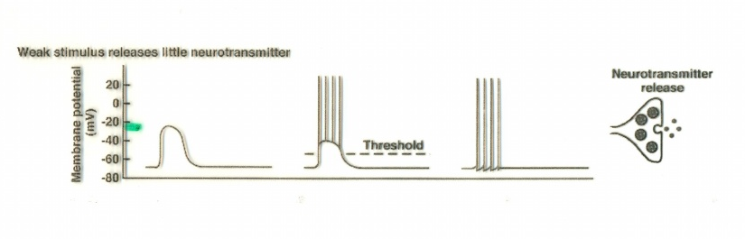

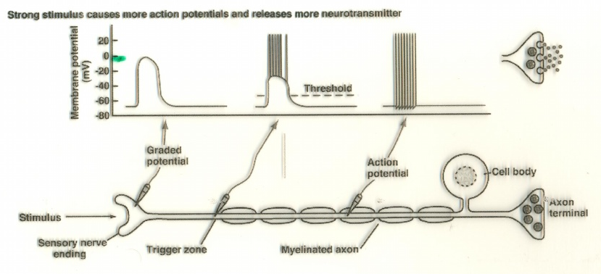
However if the graded potential reached 0MV instead of -20MV, which is of course a stronger and more intense stimulus, the amount of neurotransmitters produced will also increase. This is the way in which the human brain knows that the stimulation is stronger. (image below)

So some of you might be wondering why we are talking about voltage..
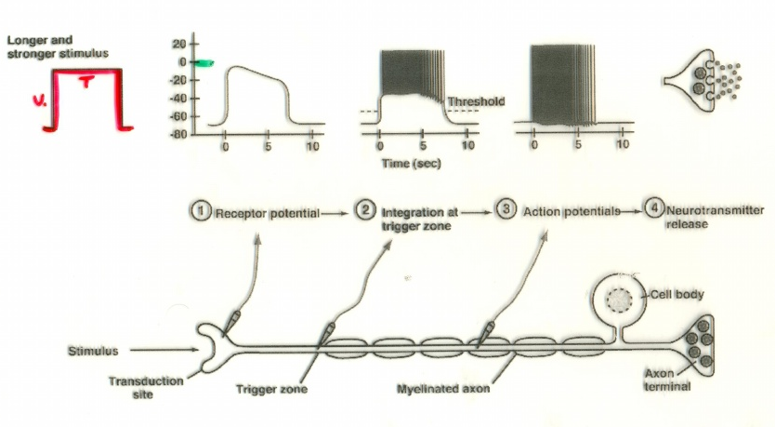
As you can see in the ‘square pulse’ diagram below, it is characterized by voltage and timing, and depends on the input of electricity, and the duration through which it stays in the viable tissue. This will cause a graded potential that lasts longer and higher (stronger and more prolonged).
Notice that the frequency of the action potential is much higher, and the neurotransmitters are secreted in higher concentrations indicating alterations in the activity of the brain.
In conclusion; the brain knows that there is a change in activity when there is a change in:
- Amplitude / Magnitude of the graded potential
- Frequency of action potentials
- Concentration of released neurotransmitters
------------------------------------------
Moving on to the chemistry of the brain and some of its abnormalities in relation to the neurotransmitters..

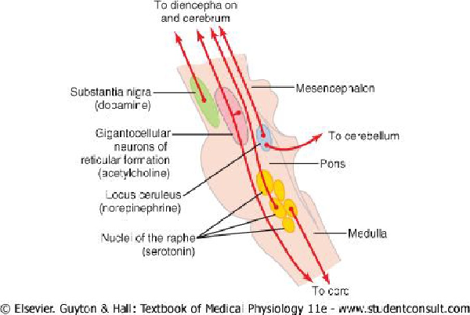

The figure above shows the area of the brain known as the Brain Stem; the lower part of the brain, which can be fatal upon injury – also known as the area of survival.

The brain stem is the site of the major neurotransmitters of the brain. There are four major nuclei which spread neurotransmitters to the brain, as seen in the image.
The first one we will discuss is the Substantia Nigra. This is a group of cells which are present in the mid brain, or the upper part of the brain stem, and it secretes the neurotransmitter known as Dopamine.
Keep in mind that the above shown nuclei were named by scientists either because of their colour, or their shape. Thus; Nigra from negro (meaning black), and Substantia from substance – Black Substance / Point.
-----------------------------------------
We will first discuss the normal physiological effects of Dopamine, and then move on to the pathological effects of Dopamine when it is present in abnormal levels.
Dopamine is responsible for giving us a smooth movement, for example when running, moving your arms, walking..etc, it prevents your muscles from becoming stiff. In addition, Dopamine is also a mood stabilizing neurotransmitter.
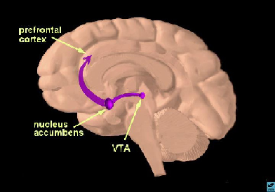
When Dopamine is high in your brain, you feel happy and euphoric. While when it decreases, it gives you a feeling of depression and sadness. It is thus called the neurotransmitter of romantic love.
In an experiment conducted by Helen Fischer, a well known anthropologist, she brought 37 young individuals who are deeply in love, and imaged their brain using the functional MRI (magnetic resonance imaging), which shows us which parts of the brain are hyperactive due to the high intake of glucose and the increase in blood supply to that specific region. Helen Fischer found that in all the individuals, the VTA (ventral tegmental area) – pleasure centre of the brain is lighting in comparison to the rest of the brain regions. She also proved the theory that when you are in love, dopamine is high.
In the following experiment, she brought a similar group of young individuals whom had recently been dumped, and scanned their brain to see the difference. She noticed that the VTA and the nucleus accumbens regions of the brain are still active, indicating that even if you have recently been dumped you cannot immediately stop the feelings of love.
However she also noticed that other parts of the brain including the risk-taking and calculations parts of the brain were also activated, explaining why people act without thinking after being dumped (due to miscalculations).
The above descriptions all explain the normal physiological state of dopamine in the human brain.
----------------------------------------
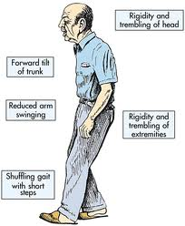
Now when Dopamine is at a low level in the human brain, especially in the elderly, this will lead to Parkinson’s disease.
Parkinson’s disease is characterized by the following:
- Pill-rolling – hands shaky and 4-5 hertz tremor
- High rigidity – unable to flex / extend arm normally
- Speech impairment
- Forward tilt of the trunk – instability of gait
It is rarely exposed to young people except when they are exposed to chemicals or toxins.
The type of tremor they have is called a resting tremor, and hence, when asked to hold a glass of water for example, the tremor stops.
Parkinson’s disease is due to the decrease in the level of Dopamine in the Substantia Nigra as a result of the destruction of the cells which release this neurotransmitter in the nuclei.

*The treatment for this decrease in Dopamine is L-dopa (Levodopa), a type of synthetic dopamine which is able to cross the blood-brain barrier in the body.

- 80% of diseases are without treatment, and idiopathic (unidentified cause)
But this does not mean that when a patient comes to a doctor the doctor does not offer any help.. Nowadays doctors can surgically implant electrodes in the brain which stimulate Substantia Nigra hoping to release dopamine. However it does not mean that the problem is cured.
The only real cure for these diseases are stem cells, which remain under trial until today. (by synthesizing dopaminergic cells and implanting them into the patient’s brain hoping that they will begin to secrete dopamine and cure the problem)
-----------------------------------
When Dopamine is abnormally high, it will lead to Schizophrenia.
Usually occurs in young males, who are highly intellectual.
Schizen – split ; Phrene – mind
Two types; acute & chronic
Schizophrenic patients usually think that people are going to try to poison them, or are consistently talking about them in front of them. This is called delusions.
Patients will also experience hallucinations due to the high levels of dopamine, like feeling someone touch them when actually no one is around, or feeling as though someone is trying to strangle them.
However the most important and the diagnostic criterion of Schizophrenia is the auditory hallucinations. (other previously mentioned criteria may occur in other diseases)
For example if a patient tells the doctor that he can hear two people talking, referring to him, saying that he is so stupid, or is a social outcast, and must go kill himself.. and this may lead schizophrenic patients to eventually commit suicide.
There is also genetic predisposition, in other words there is a 40-50% chance that if a close family member has schizophrenia, then the other family members may also eventually develop this disease. Chromosome 5 has been incriminated to have a relation with schizophrenia. Environmental factors also influence the development of this disease through stressful situations..etc.
In conclusion, schizophrenia is a ‘splitting of reality’.

The doctor then asked a question; “if I treated a patient whom had had schizophrenia, but after a few weeks the patient returns with a tremor and constant shaking, what does this indicate?”

It indicates that we gave the patient a too-high dosage of dopamine-suppressants which made it drop below the normal level, causing manifestations of Parkinson’s disease. (by blocking the D2 receptors)

Another question; “if the wife of a parkinson’s disease patient comes to my office and tells me that her husband keeps talking to himself, what does this mean?”

It means that we gave the patient too-high dosage of L-Dopa, increasing the levels of dopamine in the brain over the normal level, causing manifestations of Schizophrenia.

All the best
Zakaria W. Shkoukani

