1.Which of the following statements is correct?
(a) It is safe to consume as you want from the OTC druge.
(b)Always you should write the drug chemical name in your prescription .
(c) For adrug with high plasma protein binding capacity, lower plasma protein level in children means that the free drug will be less.
(d) absorption is always more in adults than children.
(e) Stopping a drug can be a cause of an adverse effect.
2. Which of the following statements is correct ?
(a) the risk:benefit ratio for any drug is fixed for both adults and children.
(b)As a clinician, you should always consider the pharmacological therapy first.
(c) Always apply a pill for every ill.
(d) The side effect may develop of your patient is not takingthe full prescribed dose.
(e) The drug safety decreases if the TD50/ED50 ratio increases.
3. Which of the following statements is correct ?
(a) The large the E50 the greater the potency.
(b) Half-life of elimination is the time to reach steady state concentration.
(c) Potency is indicated by the height of the log dose response.
(d) Variation in response to drug among different individuals is most likely to occur with a drug showing a large therapeutic index.
(e) The drug effect can be a side effect in one setting and a therapeutic effect in another setting .
4.Which of the folloeing statements is correct ?
(a) If 10 mg of drug A produces the same response as 100 mg of drug B, ten drug A is more effious than drug B.
(b) Skipping a dose is not important in calculating the time to reach steady state.
(c) The increase in total body fat usually results in an increase in the half life of water soluble drugs.
(d) Generally, Reduction in the oxidative metabolism through cytochrome P450 system result in a reduction in the drugs clearance.
(e) None of the above.
5.when two drugs with the same effect give together and produce an effect that is greater in magnitude than the sum of their effects when the drugs are given individually, we called this:
(a) Competitive drug effect.
(b) Additive drug effect.
(c) Potentiation drug effect.
(d) Chemical drug effect.
(e) Synergic drug effect.
6.Which of the following routes of administration is the most variable and involve most complication to the tissues?
(a) Oral route
(b) Subcutaneous.
(c) Intravenous
(d) Inhalation
(e) Intramuscular
7.First pass effect occure most ofen after of the following route of drug administration ?
(a) Oral route
(b) Subcutaneous.
(c) Intravenous
(d) Inhalation
(e) Intramuscular
8.Hydrophilic drug with a law molecular weight is most likely to distribute to which of the following compartments:
(a) Extracellular
(b) Plasma
(c) Total body water
(d) a + b
(e) a+ b + c
9. Which of the following statements is correct ?
(a) In competitive antagonism a higher concentration of agonist is is agonist is necessary to achieve the therapeutic effect of the agonist.
(b) With competitive antagonism, the dose effect curve is shifted to the left.
(c)Competitive antagonism is produced by antagonists that have the ability to activate receptors.
(d) Emax dose not depend on the number of druge-receptor complexes formed.
(e) None of the above
10. Which of the following statements is correct ?
(a) If the TD50 is much higher than the ED50 then the drug is described as anarrow therapeutic drug.
(b) It is safe to give dose in excess of drug with narrow therapeutic index.
(c) In selecting adrug, potency is usually more important than efficacy.
(d) hypersensitivity reaction is classified as augmented (dose dependent) drug reaction.
(e) None of the above.
11. Which of the following statements is correct ?
a) Many trade name of adrug like paracetamol may results in high incidence of drug toxicity if the doctor always writes in their prescription the generic name.
b) Regardless the receptor tissue site, activation of a receptor in the body always produces the same effect.
c) Transdermal rout offer stable drug blood levels.
d) Intranasal rout is another name for inhalation rout.
e) If adrug moves through the GI tract very quicly , the drug absorption is increased.
12. The ligand must have a high lipid solubility to which of the following receptors.
a) The ligand-gated ion channels
b) G protein-coupled receptors
c) Enzyme-linked receptors
d) Intercellular receptors
e) all of the above
13. The figure below shows the Time course of drug concentration of oral , intravenous , intamascular . and subcutaneous routs.
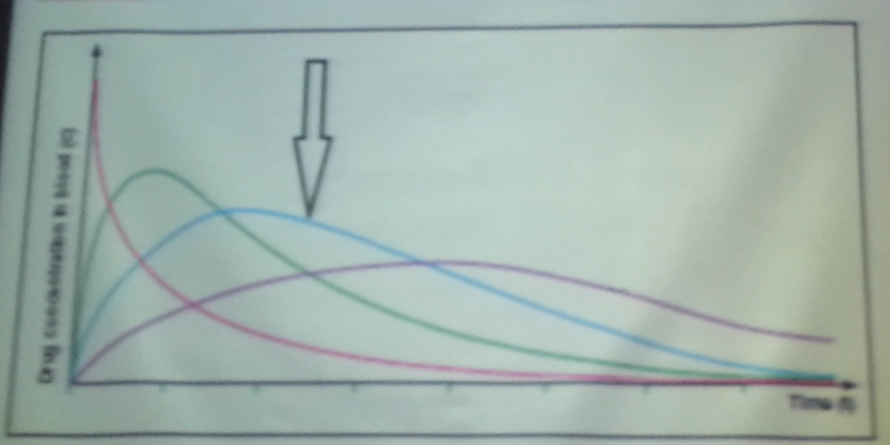
The arrow in the figure is pointed toward the time course of drug concentration of
a) Oral
b) Intravenous
c) Intamascular
d)subcutaneous
e) Both oral and intamascular
14. Which of the following rout of administration has the greatest rist of developing adverse effect ?
a) Oral
b) Intravenous
c) Intamascular
d)subcutaneous
e)Rectal
15. Drug A is metabolized by CYP 3A4 increase with age. The clearance of drug A goes from 1.2 ml/min/kg in the first month to 9 ml/min/kg at age of year.
Which of the following statements is correct ?
a) You should prescribe less amount of drug A to the 1 yaer baby than the baby with age of 1 month.
b)The dose prescribed at the two ages shoud be equal.
c)The half life of drug A in the 1 month baby is more than the half life of drug in 1 year baby.
d) You shoud never prescribe drug A to the baby at age of 3 month.
e) The 3 month prescribed dose should be 12 folds less than the 1 year prescribed dose.
16. Which of the following statements is correct ?
a)The pharmacodynamic of drug in children and is always similar as the drug targets do not differ with age.
b) The metabolism of drug in children is always less than that in adults.
c)when the creatine clearance decrease in your patients you shoud decrease the dose for those drugs that eliminated through kidney .
d)from pharmacogenomics point of view, "One pill fits" all is a right statement.
e) Non of the above.
17.If your patient is elderly and has a reduction in total body water increase in total body fat, in comparision with a normal adults, which of the following statements is incorrect ?
a) For a water soluble drug, the serum level is usually higher than that in the normal patients.
b) For a fat soluble drug, the amount of the drug in the fat is usually higher than that in the normal patients.
c) For a fat soluble drug the half life is longer.
d) For a water soluble drug the volume of distribution is higher.
e) Non of the above.
18. A patient with ultra rapid CYP 2D6 phenotype and you have prescribed him drug A that is Fully metabolized by CYP 2D6 . Note that the metabolite of the drug A dose not cause adverse effect.
In comparison with extensive metabolizer patiet. which of the following is incorrect ?
a) The patient is less susceptible to drug a adverse effect.
b) The patient usually benefits more from drug A.
c) The patient has higher drug A clearance.
d) The patient has shorter drug A haf life.
e)for this patient, you shoud increase drug A dose.
19.If your patient is taking drug A and B you prescribed him drug B , after which he start to suffer from a side effect that known to be caused by drug A. which of the following is not apossible cause?
a) Drug B may displace drug A feom the blood protein binding site.
b) Drug A and B are actively exereted from the same nephritic site.
c) Drug B enhanced the enzyme that responsible for drug A metabolism.
d) Drug B increase the absorption of drug A.
e) Drug B has the same side effect as drug A.
20. When your patient has only one CYP 2D6 functional allele, then the phenotype classification of your patient is:
a) CYP 2D6 Poor metabolizer (PM)
b) CYP 2D6 intermediate metabolizer (IM)
c) CYP 2D6 Extensive metabolizer (EM)
d) CYP 2D6 Ultrarapid metabolizer (UM)
e) Non of the above
21.A loading dose is used to :
a) Incresed the drug half life
b) Incresed the bioavilability of the drug
c) Quickly reach the steady state
d) Increase the elimination rate of the drug
e) Increase the drug concentration in the brain
22. One drug acting on the sympathetic nervous system causing the heart rate to increase and causing vasoconstriction ; while another drug acting on the parasympathetic nervous system decrease the heart rate and causes vasodilatation, is an example on:
(a) competitive antagonism
(b) non- competitive antagonism
(c) physiological antagonism
(d) chemical antagonism
(e) non of the above
23.The maximum effect (Emax) zchieved by adrug is measure of:
a) potency
b)Efficacy
c)the equal response
d) antagonism magnitude
e) the therapeutic index
24. In case of liver disorders accompaninied by a declin in CYP450 enzyme activity the duration of action of some drug is:
a)decreased
b)Enlarged
c)remained unchanged
d)changed insignificantly
e)all of the above
25. A patient with poor CYP 2D6 phenotype and you prescribed him a pro-drug with normal (not adjusted) dose. This pro-drug is fully activated by CYP 2D6. In comparison with extensive metabolizer patient, which of the following statements is correct?
a) The patient is less susceptible to the pro-drug adverse effect
b) The patient should benefit more from the pro-drug
c) The patient has faster pro-drug clearance
d) The patient has shorter pro-drug half life
e) The patient usually has less active drug concentration in blood

