Mnemonics for biochemistry
Fuctions of plasma proteins
Genral functions
😉?😉?😉?😉?😉? now picture a new player in ateam and all what he can do is GENERAL skills like passing this guy is called a NOVice Player
1 . Nutrition
2 . Oncotonic pressure
3 . Viscocity
4 . PH of blood
Specialized function
Now this player has tranied hard and now he is THE CHamp he only plays in sepcific mathches
1 . Transport
2 . Humoral immunity
3 . Enzymes
4 . Coagulation
5 . Hormones
Things that bind albumin
Picture a Flappy Sand Bag filled with Tasty Muffins its just like that plasma containig tube with the cute albumin in it
F . Free fatty acids
S . Steroids
B . Bilirubin
T . Tryptophan
M . Menerals
and dont forget your drug after eating the muffins ;)
Ps flappy مترهل
the drugs that bind albumin
Picture this SAD Pac man , he did get all the drugs out there
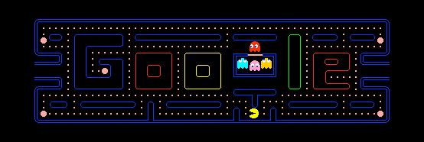
1 . Sulfoaminades
2 . Aspirin
3 . Dicumarol
4 . Pencillin G
causes of hypoalbumenia
Picture the Mad Nasty CG
1 . Nephrotic syndrome
2 . Malnutrition
3 . Cirrhosis
4 . Gastroinstestinal loss

