Innate and acquired immune system

♣ This sheet was written according to sec1
♣ I rearranged a lot of topics here and there and I've added some information from wiki for further clarification. So don't be confused when referring to the original recording
♣ Also, this is an easy lecture, enjoy.
.
♦Types of immune reaction
We've mentioned in the last lecture that there are two types of the immune reaction;
1) Innate
2) Acquired
In this lecture we are going to talk about each one in more detailed
The innate immune system
•it is the first line of defense in the human body. It can be;
- Physical: like the skin
- Chemical like our sweat which provides an acidic environment. Also it's full of peptides which act as antibiotics that can kill bacteria
- Mucosa: it's not exactly a physical barrier however it traps pathogens from entering our cells, as an example; our respiratory system, eventually you'll dispose the mucus by swallowing or spitting it.

•Accessory glands in the mucosa:
Like the salivary glands; produces saliva that contains lysozymes which as you know contains enzymes with the capability of degrading polypeptides, thus they are affective against gram positive bacteria.
•The continuous flushing
of these secretion can help as well, as we can see in the urine, continues flushing can help in getting rid of pathogens.
•PH value;
In our stomach the low PH and the high PH in our small intestine can also help in killing and digesting these nasty pathogens
•Our normal flora
can be considered as part of our innate system, that some types produces polypeptides as a part of their lifestyle, for example the acidic medium in the vagina is due to its normal flora, that can help in preventing fungal infection there.
•Phagocytes:
As we know macrophages and neutrophils are considered the first line of defense at the cellular level, they recognize bacterial antigens like mannose sugar, lipopolysaccharides, bacterial DNA, RNA fragments and flagella on its surface. The killing effect is done by phagosomes. Phagocytes actually act in both the acquired and the innate system; it doesn't only phagocytes the pathogens, it also presents bacterial antigens on its surface.
<keep in mind •phagosome is a vesicle formed around a particle absorbed by phagocytosis. The vacuole is formed by the fusion of the cell membrane around the particle. •A phagosome is a cellular compartment in which pathogenic microorganisms can be killed and digested it fuses with lysosomes in their maturation process, forming phagolysosomes>
•Complement proteins
It is a collection of proteins that are activated in sequence like a cascade, something similar to the coagulation system, the complementary system actually divides the innate system from the acquired, meaning; it is activated in both the innate and the acquired responds. They don’t only promote phagocytosis but also, they can lyse the cell membrane of the pathogens.
•interferon;
when cells are infected with viruses they produce interferons so the other immune cells attack it, by doing that it sacrifice itself for the sake of eradicating the virus *brave soldiers*
•fever
In most times it means inflammation or bacterial infection, it has been thought that our body has adopted this mechanism so it can kill those pathogens with heat, but what really happens here is that; bacteria needs iron to synthesis her needed enzymes, they uptake them from our body those bastards by producing siderophores which absorbs iron from the environment for the sake of this organism, anyway, with heat this process is stopped. Hah.
•Acute-phase proteins
- Are a class of proteins whose concentrations increase in response to inflammation. This response is called the acute-phase .In response to injury or local inflammatory cells (neutrophil, granulocytes and macrophages) secrete a number of cytokines into the bloodstream, most notable of which are the interleukins mainly IL5 and IL6, and TNFα. The liver responds by producing a large number of acute-phase reactants

- Acute-phase proteins serve different physiological functions for the immune system. Some act to destroy or inhibit growth of microbes, e.g., C-reactive protein, mannose-binding protein, complement factors

- C-reactive protein; was so named because it was first identified as a substance in the serum of patients with acute inflammation that reacted with the C-polysaccharide of Pneumococcus. Although it does react with many types of bacteria acting like immunoglobulin, but of course it's not an antibody because it's not specific. It is thought to activate complement protein binding to foreign and damaged cells and enhances phagocytosis by macrophages

- Another similar acute phase protein is mannose binding protein, again it's nonspecific binds to mannose sugar bacteria, by this it provokes the immune response

Now, if we have an infection we tend to use ESR test, as you know the ESR is a nonspecific test so it is typically used in conjunction with other tests, such as C-reactive protein. If were tested positive these level should be high.
♦As we know defenses can be either inside the cell or excreted outside to the circulation and these are polypeptides that mainly work on membranes that don't contain steroid i.e. membrane of bacteria.
• NK cells,
- these natural killer cells can recognize abnormal cell which could be viral infected cells, cancer cells or even foreign cells, this recognition occurs by their special receptors; like for example MSHC 1 receptors, if present the NK holds its fire, otherwise it stigmatize them as a harmful subject and stick on them the "kill me" signal.

- (MICA and MICB); MIC proteins are considered to be markers of "stress" in the epithelia, they are expressed by the stressed cell and located on its surface, acting as ligands for natural killer-cell receptor (NKG2D)

Acquired immune system

When we talk about Acquired immune system the first thing cross our minds "antigens-antibodies interaction";
Talking about receptors, antigen receptors for B and T lymphocyte are BCR and TCR respectively; they are responsible for recognizing antigens bound to (MHC) molecules.
TCR: is always cell-bound, always on the surface of cells.
BCR: we have two forms;
A) one is cellular (on membrane of B cells) which is also called BCR-proper that is bound to the cell surface just like the TCR,
B) and the other is secreted in the circulation and known as antibodies. ◘Antigens, antibodies and their receptors
First, lets talk about Antigens;
•It is a molecule that binds with its antibody with high specificity
•If this antigen develops an immune reaction then it's called an immunogen
•If this antigen is too small(less than 6kd) to be recognized by antibodies we call it haptin, those haptens binds with other proteins –like a carrier- for them to be seen and be immunogens, because the bigger those antigens are, the better they'll be recognized -obviously- otherwise they can be there kept unseen.
•If their structures are more complex they are more easy to get recognized, that’s why polysaccharides and nucleic acids can't be recognized well because they are made of repetitive units, I mean they can be recognized but not that well… unlike of course "proteins" which can be seen easily with their tertiary structure and everything .

♦The doctor mentioned these antigens at the end of the lecture and said "we'll be talking about them in the coming lectures…"
•Endogenous antigens
Are generated within normal cells as a result of normal cell metabolism, or because of viral or intracellular bacterial infection. The fragments are then presented on the cell surface in the complex with MHC class I molecules.
• Exogenous antigens
Are antigens that have entered the body from the outside, for example by inhalation, ingestion or injection
• Neoantigens
Are those that are entirely absent from the normal human genome.
•Superantigens
Are a class of antigens that cause non-specific activation of T-cells resulting in polyclonal T cell activation and massive cytokine release. SAgs are produced by some pathogenic viruses and bacteria most likely as a defense mechanism against the immune system.[
Vaccination
This antigen antibody thing can be implicated in the vaccination field, the thing is, if you want to produce an antibody for "X antigen", you simply inject that antigen in a human or animal so its immune system will create a highly specific antibodies for the sake of destroying it. Later on these antibodies stay in their circulation hunting and looking for that X antigen in case if they appeared again.
We must make sure that the body have produced antibodies from those antigens in the vaccine shots, so we must administrate it slowly to make sure the body has reacted with it properly. Giving it orally can damaged those antigens before our immune system can react with them, so we introduce it intramuscularly or subcutaneously to have our desired result.
Giving those vaccines intravenously would be a waste of a good needle because those antigens will be cleared in no time leaving us with no trace or memories ;_;
Some proteins called " adjuvant " may be added to those antigens, they have the power of dissolving the antigens and releasing it gradually. Other types are called "Freund's adjuvant" have an irritating effect and may be toxic, this irritation is needed to make sure large quantities of macrophages are there to eat up all these antigens, that’s why some vaccine shots can be painful. However, Freund's adjuvant is not introduced in normal vaccine instead aluminum hydroxide is used in order to dissolve the antigen and release it gradually.
•Freund's adjuvant is a solution of antigen emulsified in mineral oil and used as an immunopotentiator (booster). The complete form, Freund's Complete Adjuvant is composed of inactivated and dried mycobacteria.

Immune responses can in many situations depend on the genetic make-up, that's why the severity of the responses can vary from a species to a species, even from a person to another. They are called the immune response genes, they are nothing but MHC1&2, some of these can be defected, that’s why some of you may catch a flu more than 5 times a year, and others once every 5 years.

Now let us talk about antigens and antibodies structurally.
We've talked about antigen previously, antibodies on the other hand are a Y shaped proteins. The site of contact between the two of them is only a several amino acids called epitopes.
Epitope
Also known as antigenic determinant, is the part of an antigen that is recognized by the immune system, specifically by antibodies
Some antigens can have more than one type of epitope, these are called multivariate antigens. Different types of antibodies can bind to the same antigen due to this variation. Unlike hapten, this poor thing only has one epitope.
Epitopes are divided into two categories;
• conformational epitopes
• linear epitopes,
Based on their structure and interaction with the antibody. A conformational epitope is composed of discontinuous sections of the antigen's amino acid sequence. These epitopes interact with the antibody based on the 3-D surface features and shape or tertiary structure of the antigen. linear epitopes interact with the antibody based on their primary structure. A linear epitope is formed by a continuous sequence of amino acids from the antigen.
•So if you unfolded both types, the linear is not going to be affected.
•Epitopes can also exist inside the antigens not only on their surface,
•Paratope; is the site of the antibody which recognizes the epitopes-wiki
Now what exactly determines the interaction between antigens and their antibodies?
It's not a covalent interaction; the affinity is caused by several types of bonds,
1) The shape of each one so they can fix on each other
2) Electrostatic force
3) Hydrogen bonds
4) Van der waal forces
5) Hydrophobic force
6) Avidity: refers to the accumulated strength of multiple affinities of individual non-covalent binding interactions, such as between a protein receptor and its ligand, and is commonly referred to as functional affinity. As such, avidity is distinct from affinity, which describes the strength of a single interaction. However, because individual binding events increase the likelihood of other interactions to occur (i.e. increase the local concentration of each binding partner in proximity to the binding site), avidity should not be thought of as the mere sum of its constituent affinities but as the combined effect of all affinities participating in the biomolecular interaction. Biomolecules often form heterogenous complexes or homogenous oligomers and multimers or polymers. If clustered proteins form an organized matrix, such as the clathrin-coat, the interaction is a described as matricity.
That's it! Good luck on your midterms
Done by, Mohanned Momani
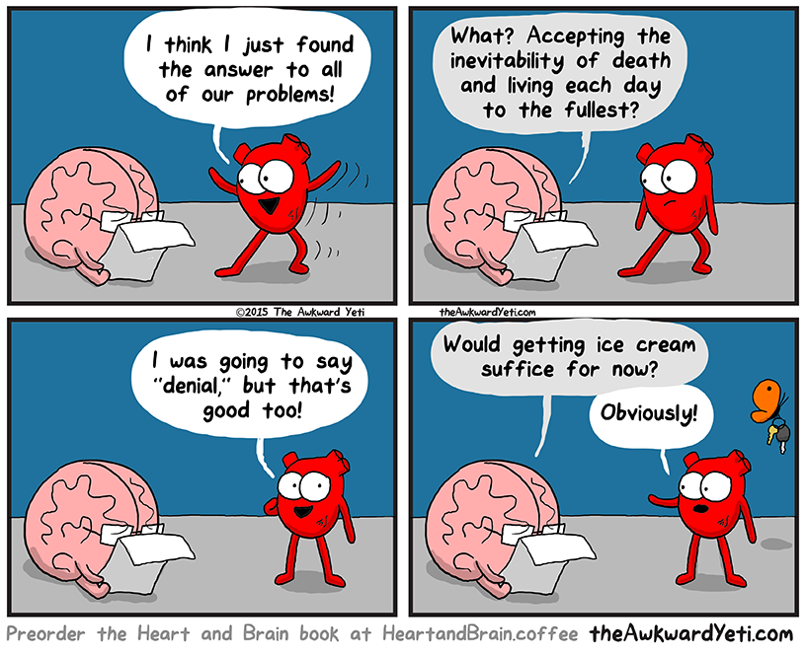
Dedicated to mazen hindi for not helping me at all :p. And a special thanks goes to Tariq Bushnaq and Hamzeh Salameh

