Gastrointestinal system questions

Anatomy ,Histology and embryology
- All of the following about the oral cavity is correct except :

- The vestibule receives the opening of the parotid duct at the upper second molar tooth
- The vestibule is the space between the lips and cheeks anteriorly and the gums posteriorly
- The posterior 1/3 of the tongue is supplied by The glossopharayngeal nerve for general sensation
- All the muscles of the tongue are supplied by the hypoglossal nerve except genioglossus muscle
- Minor salivary glands are distributed all over the oral mucosa and they secret mucus

- All the muscles of the palate are supplied by the pharyngeal plexus of vagus nerve except :
- levator veli palatine
- palatoglossus
- palatopharyngeus
- Tensor veli palatine
- Musculus Uvulae
3-About the nerve supply of the major salivary glands which of the following is correct :
A-The parotid gland is supplied by the inferior salivary nuclei of the facial nerve
B- the submandibular and sublingual glands are supplied by different salivary nuclei
C-post-ganglionic parasympathetic fibers that supply the parotid gland arise from the submandibular ganglion
D- The submandibular gland is supplied by the superior salivary nuclei of the glossopharyngeal nerve
E-Pre-ganglionic parasympathetic innervations of the sublingual gland is carried by the lingual nerve .

- Fecal incontinence is most commonly caused by damage to which of the following structures :
- Inferior rectal nerve
- Internal anal sphincter
- Anal columns
- Upper part of the anal canal
- Piriformis muscle
5-Peptic ulcer in the first inch of the duodenum causes bleeding from which of the following arteries :
- Celiac artery
- Left gastroepiplioc artery
- Superior pancreaticoduodenal artery
- Gastroduodenal artery
- Superior mesenteric artery
6-About the appendix which of the following is false :
- In children germinal centers hyperplasia can cause obstruction of the appendix lumen which leads to appendicitis
- In the surgery to treat appendicitis an incision is made parallel to the inguinal ligament and pass through McBurney's point
- The appendix is most commonly found in the subcecal position
- To eliminate the blood supply of the appendix , the surgeon ligate the appendicular artery in the mesoappendix
- The referred pain from appendicitis usually starts around the umbilicus
7-about the histology of major and minor salivary glands which of the following is wrong :
- The parotid gland is a branched tubuloacinar gland
- Intralobular ducts of the parotid gland are lined by stratified squamous non-keratinized epithelium
- Submandibular glands contains mucus cells with serous demilunes
- The intralobular ducts of The sublingual gland are not well-developed
- Von-Ebner's glands secret purely serous fluid
8-about the histology of the esophagus which of the following is wrong :
- The muscularis externa of the upper third of the esophagus is made of skeletal muscles from the inferior constrictor muscle
- The lamina propria of the lower third of the esophagus contains glands
- The only organ in the GI tract with glands in the submucosa is the esophagus and they are called esophageal gland proper
- The only way to distinguish the thirds of the esophagus is by the muscularis externa
- Most of the outer surface of the esophagus is lined by adventitia
9- about the histology of the stomach which of the following is wrong
- The lining epithelium is simple columnar epithelium without goblet cells
- The body of the stomach contains larger gastric gland compared to the gastric pit
- The cardia of the stomach contains larger gastric pit compared to the gland
- Mucous cells are found in the isthmus of the gland and they secret the lining of the stomach while chief cells are found in the base
- The pylorus has thickening of smooth muscles in the muscularis mucosa forming an anatomical sphincter
10- about the histology of the large intestines which of the following is CORRECT :
- There is no vili in the large intestines and they are replaced by microvili
- Paneth cells are presented at the base of crypts of liberkuhns of the large intestines
- The outer longitudinal layer of muscularis externa in the appendix forms 2-3 ribbons of smooth muscle
- Appendices epiploica are tags of fat projecting from the adventetia of the large intestines
- The large intestines contains numerous neuroendocrine cells compared to the small intestines
11-About the histology of the liver which of the following is wrong :
- Blood sinusoids are found at one side of each hepatocyte while bile ductules are found on the other side
- The classical lobule of the liver contains central vein in the middle and portal triad at the corners
- Glisson's capsule divides hepatic lobes into lobules
- Hepatic artery is the largest structure in the portal triad
- Blood sinusoids are made of fenestrated endothelial cells
12-About the pharynx which of the following is incorrect :
- Eustachian tube is found in the lateral side of the nasopharynx
- Dilated Ala of the nose , mouth breathing and troubles in exercise are all the characteristics of pharyngeal adenoid
- All the muscles of the pharynx are supplied by glossopharyngeal nerve except stylopharyngeus muscle
- The laryngopharynx is supplied by the internal laryngeal nerve for general sensation .
- Deep cervical Lymph nodes are removed in case of squamous cell carcinoma of the pharynx to eliminate possible lymph metastases
13- A patient was admitted for tonsillectomy surgery and it was successful , after the surgery the patient was asked to swallow then perfuse bleeding happened . which of the following vessels was damaged ?
- Paratonsilar vein
- Tonsilar branch of facial artery
- External palatine artery
- Ascending pharyngeal artery
- Internal carotid artery

14- all of the following lies posterior to the 3rd part of the duodenum except :
- Right ureter
- Right psoas muscle
- Abdominal aorta
- Inferior vena cava
- Origin of the Superior mesenteric artery
15- All of the following about the anterior abdominal wall is correct except :
- The external oblique and internal oblique muscles have the same nerve supply
- The landmark to distinguish direct from indirect inguinal hernia is the inferior gluteal artery
- Anterior wall of the rectus sheath above the xiphoid process is made by external oblique muscle
- Posterior wall of rectus sheath below the umbilicus is only made by fascia
- Venous drainage of the umbilicus is a site of porto-systemic anastomoses
16- all the following about the posterior abdominal wall is correct except :
- the lumbar vertebrae are devoid from facets and foramens on the transverse process
- The most important paired branches from the abdominal aorta include : testicular +ovarian arteries , median sacral artery , renal arteries
- The right renal vein is not related to the abdominal aorta
- Hepatic vein and renal veins are some of the tributaries to the IVC
- Cysterna chyli is found on the right side of the aorta and it contains most of the lymph from the abdomen

17- porto-systemic anastomoses is found in all the following sites except :
- Lower third of the esophagus
- Inside the liver
- Fundus of the stomach
- Rectum
- Umbilicus
18-About omphalocele all the following are correct except :
- It is caused from a defect in the muscles of the anterior abdominal wall
- It is an unreturned physiological hernia of the midgut
- It is associated with high rate of mortality and malformations
- It is associated with chromosomal defects
- The abdominal content are usually herniated directly to the amniotic fluid
19- all the following structures are formed by the Dorsal pancreatic bud except :
- Neck of the pancreas
- Body of the pancreas
- Tail of the pancreas
- Superior part of the head of pancreas
- Uncinate process of the pancreas

20-a 1 week year old newborn can't stop crying ,he has a distended abdomen , projectile vomiting that covered his mom's face .These are all characteristics of :
- Esophageal atresia and fistula with the trachea
- Pyloric stenosis
- Esophagial stenosis
- Necrotizing enterocolitis
- Pancreatic divisum

Microbiology
21-all of the following is associated with Clostridium perfringens except :
- Food intoxication
- Meningitis
- Blood sepsis
- Diarrhea
- Vomiting
22- All of the following is associated with Bacterial food poisoning except :
- Fever
- Diarrhea
- Vomiting
- Abdominal pain
- A+C
23- all of the following is associated with entamoeba histolytica pathogenesis except :
- It can be asymptomatic in some patients
- It differs from E-dispar by the presence of virulence factors
- Perforation ,peritonitis and liver abscess are all possible complications
- At late stages of the infection the patient might develop liver cirrhosis
- None of the above
24-all of the following is associated with giardia lamblia except :
- It has 4 pairs of flagella sticking out laterally
- It has a sucker on the ventral site
- It's trophozoit has 4 nuclei mimicking an owl eye appearance
- It is associated with mal-absorption
- Diagnosis is done by looking for cysts in the feces

25- all of the following are correct combinations except :
- Balantidium coli -<Cytosome
- Strongyloids Stercoralis -< Autoinfection
- Fasciola hepatica -< Jaundice
- Echinococus granulosus -< Cassoni test
- Enterobius Vermicularis -<Lemon shaped eggs
26-Which of the following is correct about Echinococus granulosus :
- Adults worms are found in the large intestines of dogs
- Cysts are found in one place in the body
- It is made of 1000+ proglottids
- It is not associated with Anaphylaxis
- Cassoni test gives a false negative result
27-all of the following about Taenia Solium is correct except :
- It measures about 2-4 meters
- It has more than 2000 proglottids
- It is possible that humans become an intermediate host
- It is not prevalent in Jordan
- It's gravid proglottids have around 7-15 lateral branches
28- Which of the following is wrong about Hymenolepis nana :
- Dwarf tapeworm
- It has a retractable rostellum
- It has 2 membranes
- It's eggs are characterized by the presence of pollar filaments
- It requires an intermediate host
29-All of the following about viral gastroenteritis are correct except :
- Rota virus has 7 distinct groups which are capable to do genetic reassortment with each other
- Calciviruses causes cells damage by triggering apoptosis and cell lysis
- Adenovirus strain 12 plays a role in celiac disease
- Gastroenteritis caused by Astroviruses is usually self-limited and doesn't require hospitalization
- Rota virus is associated with secretary diarrhea due to enterocytes destruction and loss of absorptive villous epithelium
30- Which of the following about mumps virus is correct :
- Mumps infection in teenagers carry no significant risk of sterility
- Amylase enzyme serum level is not specific for pancreatic involvement (pancreatitis ) in a patient infected with mumps
- It belongs to paramyxoviridae family and it is a non-enveloped virus
- Pediatric infection is associated with poor outcomes compared to adults infection
- None of the above
31- all of the following about viral hepatitis is correct except :
- Hepatitis A is commonly acquired by travelers
- Hepatitis B has feco-oral transmition route
- Hepatitis D infection is usually a super infection on a pre-existing Hepatitis B infection
- Hepatitis E infection in pregnant women is associated with fulminant hepatitis
- Hepatitis B and C infection carry a significant risk of development to hepatocellular carcinoma
Physiology
32 – Blood flow to the small intestines is controlled by all the following except :
- Cholecystokinine
- Vasoactive intestinal peptide
- Bradykinin
- Interstitial cells of cajal
- Adenosine
33- all of the following about the Enteric nervous system are correct except :
- It starts from the pharynx and extends along the entire GI tract
- Neurons of the enteric nervous system are distributed into 2 plexuses
- Auerbach plexus controls the contraction of the muscularis externa layer
- Meissner's plexus controls gastrointestinal secretion and local blood flow
- None of the above
34- all of the following about esophageal peristalsis are correct except :
- If the food remains in the esophagus this will activate primary peristaltic contraction
- Secondary peristaltic contraction is a continuation of the contraction that was initiated in the pharynx
- Failure of the lower esophageal sphincter to relax will cause a condition known as achalasia
- Failure of the lower esophageal sphincter to contract will cause ulcers in lower third of the esophagus
- A+B
35- About the digestion of proteins which of the following is wrong :
- The last stage of protein digestion takes place in the intestinal lumen
- Pepsin enzyme digests about 20% of proteins to smaller polypeptides
- Brushed boarder peptidases convert smaller polypeptides into oligopeptides
- Amino acids are absorbed to the blood by either sodium dependant or independent mechanisms
- None of the above
36- One of the following regarding the contractions that appears along the colon is not true :
- The importance of Haustration contractions is spreading colonic content on the mucosa to absorb water and electrolytes
- Haustration contraction is the only contraction that moves colonic content from ascending colon to the transverse colon
- Mass contractions move the colonic content from the transverse colon to the sigmoid colon and they are presented all day long .
- Mass contractions are mediated by gastrocolic and duodenocolic reflexes
- None of the above
37-All of the following about carbohydrate digestion and absorption are correct except :
- Fructose is absorbed into the enterocytes by facilitated diffusion
- The final stage of carbohydrate digestion is achieved on the brushed border of enterocytes
- People with lactase deficiency should avoid any diary product
- Pancreatic amylase hydrolyze the α1:4 linkage between glucose molecules
- Β-glucosidase is a major brushed boarder enzyme for the digestion of starch
38- Which of the following about pancreatic secretion is correct :
- Enterokinase activates the secreted enzymes into their active form
- At high rates of pancreatic secretion HCO3- is low and Cl- is low
- At low rate of pancreatic secretion HCO3- is low and Cl- is high
- Pancreatic secretions are regulated by both neural and hormonal mechanisms
- More than one of the above
39- Lipase inhibitors are new types of drugs that treat obesity , which of the following are effects of lipase inhibitors :
- Steatorrhea
- Vitamin B12 deficiency
- Vitamin C deficiency
- Vitamin K deficiency
- More than one of the above
40-Gastric HCL secretion is increased by all of the following conditions except :
- Gastrin secretion
- Histamin secretion
- Somatostatin secretion
- Increased levels of C-AMP in parietal cells
- Enteric nervous system stimulation by release of Acetylcholine
41-In normal person feeding can be stimulated by increasing :
- Body mass index
- Basal metabolic rate
- Use of Drugs that stimulate appetite
- Depression
- None of the above
42- all of the following increase the metabolic rate except :
- Sleep
- Exercise
- Fever
- Thyroid hormones
- Sympathetic stimulation
43-which of the following is correct regarding starvation :
- Carbohydrate stores in the liver and muscles supply the body with energy in the first 2 weeks of starvation
- Ketone bodies are products of fat metabolism and they can't cross the blood brain barrier
- Proteins undergo 3 phases of depletion
- Death from starvation usually happens after 5-6 weeks
- More than one of the above
44-Mucosal block is a mechanism used for to prevent accumulation of which of the following minerals to toxic levels :
- Ca++
- Fe++
- Na+
- K+
- Cl-

Pharmacology
45-The primary pharmacological treatment of giardiasis is :
- Albendazole
- Mebendazole
- Metronidazole
- Pyrantel pamoate
- Piperazine
46-the drug of choice for the treatment of onchocerciasis is :
- Ivermectin
- Praziquantel
- Metronidazole
- Bithionol
- Pramomycin sulfate
47-Which of the following drugs has a disulfiram –like effect :
- Piperazine
- Ivermectin
- Bithionol
- Dehydroemetine
- Metronidazole
48- Which of the following antacid is associated with milk-alkali syndrome :
- Calcium carbonate
- Sodium bicarbonate
- Aluminum hydroxide
- Magnesium hydroxide
- Magnesium trisilicate
49-Which of the following drugs cause Gynecomastia , impotence , galactorrhea :
- Nizatidine
- Esmoprazole
- Methylnaltrexone
- Cimetidine
- Droperidol
50- For the management of H-pylori induced peptic ulcer a triple therapy of which of the following drugs is primarily initiated :
- Cimetidine + antacids +sulfonamides
- Omeprazole + Clarithromycin + Amoxicillin
- Omeprazole + antacids + Misoprostol
- Cimetidine + Omeprazole + Amoxicillin
- Sucralfate + Bismuth subsalicylate
51- a 6 month pregnant women complains from peptic ulcer and asked you for a medication for her disease which of the following drugs is absolutely contraindicated :
- Misoprostol
- Omeprazole
- Esmoprazole
- Sucralfate
- Nizatidine
52- the drug of choice for the treatment of hepatic encephalopathy to trap NH3 in the intestinal lumen is :
- Cascara
- Bisacodyl
- Diphenoxylate
- Lactulose
- Promethazine
53- The drug of choice for the treatment of vertigo due to labyrinth dysfunction is :
- Diazepam
- Prochlorperazine
- Meclizine
- Methotrexate
- Natalizumab

54-Infliximab is :
- is a humanized recombinant human IgG1 monoclonal antibody againt TNF
- is a pegylated (polyethyelene glycol ) humanized fragment antigen binding (fab )that bind TNF
- Is associated with increased incidence of respiratory infection through reactivation of tuberculosis
- Not effective for the treatment of refractory ulcerative colitis
- None of the above
Pathology
55- A 41 year old male with a history of chronic alcoholism has a massive hematomesis following an episode of prolonged vomiting .This most typical for :
- Esophageal laceration (Mallory weiss syndrome )
- Hiatal hernia
- Barret esophagus
- Esophageal squamous cell carcinoma
- Esophageal fistula
56- All of the following are risk factors of squamous cell carcinoma of the esophagus except :
- Hot drinks
- Chronic alcoholism
- Tobacco use
- A diet rich with fruit
- Plummer venison syndrome
57-Which of the following statements regarding carcinoid tumors of the small intestines is incorrect :
- They are a proliferation of neuroendocrine cells in the small intestines
- The neoplastic cells contains neurosecretory granules
- They are clinically silent even if metastases occur
- They are often multiple
- None of the above
58-The most common long term outcome of inflammatory bowel diseases (crohns and ulcerative colitis ) is :
- Bloody diarrhea
- Sepsis
- Vitamin K deficiency
- Colorectal carcinoma
- Constipation
59- a biopsy of the stomach show chronic atrophic gastritis of autoimmune etiology , this can be associated with all of the following except :
- Pernicious anemia
- Achlorhydria
- H-pylori infection
- Rsik for adenocarcioma of the stomach
- High serum gastrin levels
60- a 35 years old male has malabsorption .A jejunal biopsy was done and it shows flattening of the villi with chronic inflammation . the patient was noticed to have a diet rich with gluten .The best treatment for his condition is :
- Restriction of gluten from the diet
- Antibiotic therapy
- Corticosteroid therapy
- A vegetarian diet
- Partial small bowel resection
61- Seen by colonoscopy in a 41 year old male are more than 100 1cm polyps on a narrow stalk that are located in the descending colon .Microscopically they are atypical colonic type glands in this polyp . The best diagnosis is :
- Adenomatous polyp
- Inflammatory polyp
- Preutz-jehgers polp
- Ulcerative colitis
- Hyperplastic polyp

62- Pre-neoplastic conditions of the GI tract include all the following except :
- Barret esophagus
- Ulcerative colitis
- Crohns disease
- Chronic Atrophic gastritis
- Diverticulitis
63- A 65 year old male who had a history of chronic alcoholism present to the physician with ascites , dilated veins around the umbilicus ,rectal hemorrhoid .These are most likely an indication of :
- Crohns disease
- Wilson disease
- Micronodular cirrhosis
- Hepatic adenoma
- Alcoholic hepatitis
64- A 45 year old female has noted increase bronze pigmentation on her skin even though she hadn't been out in the sun , Blood tests indicates that she is diabetic , physical examination of the liver show micronodular cirrhosis . the etiology of her condition is most likely :
- Hepicidin enzyme deficiency
- Accumulation of Cu in the liver
- α-1 antitrypsin deficiency
- Budd-chiari syndrome
- Primary biliary cirrhosis
65- an 24 year old depressed girl who had been dumped by her boyfriend decided to kill herself , She intentionally swallowed all the drugs presented in her house ,6 hours later she was jaundice and was brought to the hospital the doctors told her that she require a liver transplant surgery .Her liver failure was most likely caused from which of the following drugs :
- Aspirin
- Acetamenophen
- Tetracycline
- Allopurinol
- Methyl dopa
66- The most common serum antibody presented in primary sclerosing cholangitis :
- Anti-mitochondrial antibody
- Anti-cytochrome p450 components
- Anti-tropomysin antibody
- Anti-actin antibody
- Anti-nuclear cytoplasmic antibody
67- Which of the following combinations is incorrect :
- Liver cirrhosis -< hepatic encephalopathy
- Reye syndrome –< Aspirin
- Wilson disease -< Increase plasma ceruloplasmin level
- Hepatic adenoma -< Oral contraceptive steroids
- α-1 antitrypsin deficiency -< Neonatal hepatitis
68- Elevated serum levels of α-fetoprotein is most likely an indication of
- liver cirrhosis
- Alcoholic hepatitis
- Colonic adenocarcinoma
- Budd-chiari syndrome
- Hepatocellular carcinoma
69-which of the following are risk factors for the development of gallstones :
- Pregnancy
- Rapid weight loss
- Obesity
- Gall bladder stasis
- All of the above
70- All of the following are associated with Chronic cholecystitis except
- It occurs after repeated bouts of acute cholecystits
- Bacterial superinfection can occur along with it
- It carry no significant risk of gallbladder rupture
- The symptoms of chronic cholecystits are similar to acute cholecystits
- None of the above

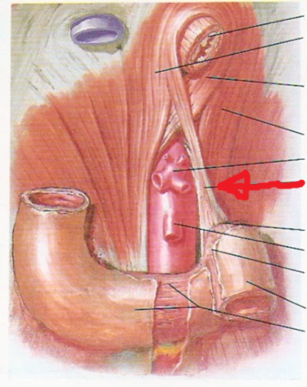
Lab questions
1- Identify the pointed structure
a) ligamentum teres
b) ligamentum venosum
c) ligament of Treitz
d) falciform ligament
e) left phrenicocolic ligament

2) Which of the following is not made from the aponeurosis of external oblique muscle?
a) Inguinal ligament
b) Pectineal ligament
c) superficial inguinal ring
d) cremastric fascia
e) anterior wall of inguinal canal
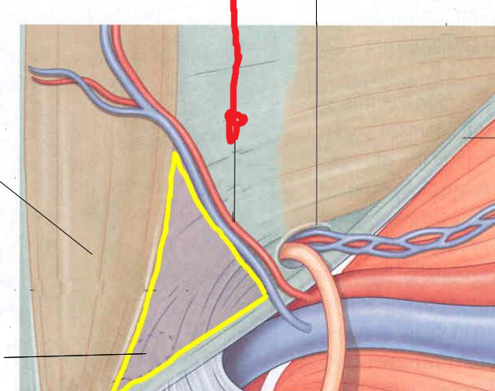
3) the following is a section from the lower anterior abdominal wall, the yellow triangle is the superficial inguinal triangle, identify the red arrow
A) superior epigastric artery
b) inferior epigastric artery
c) intercostal artery
d) superficial circumflex artery
e) lumbar artery

4) Identify the bold arrow structure
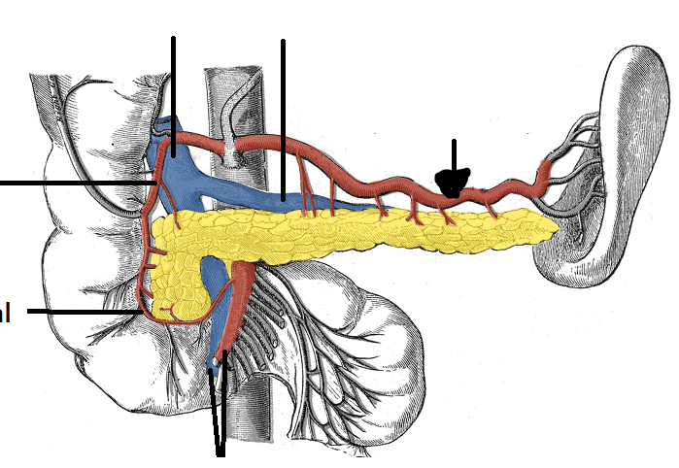A) left gastric artery
b) pancreoduodenal artery
c) superior mesenteric artery
d) splenic artery
e) celiac artery
5) Which of the following is not a content of the stomach bed?
a) left crus of diaphragm
b) body of pancreas
c) transverse mesocolon
d) lesser sac
e) Spleen

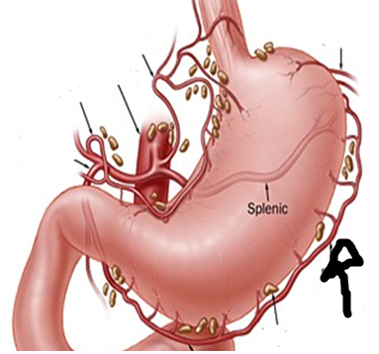
6) What is the pointed vessel supplying the stomach?
a) short gastric artery
b) right gastric artery
c) gastroduodenal artery
d) splenic artery
e)left gastric epiploic artery

7) In which of the following pouches can the infection spread upwards toward the diaphragm ?
A) right lateral paracolic sulcus
b) right medial paracolic sulcus
c) left medial paracolic sulcus
d) left lateral paracolic sulcus
e) none of the above

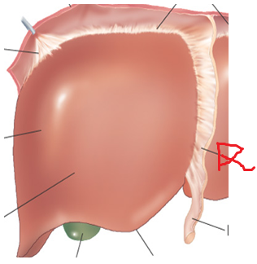
8) Identify the pointed structure
a) greater omentum
b) coronary ligament
c) ligamentum teres
d) falciform ligament
e) ligamentum venosum

9) identify the pointed green impression on the liver
a) renal impression
b) duodenal impression
c) colic impression
d) spleen impression
e) gastric impression

10) which of the following stain is used here?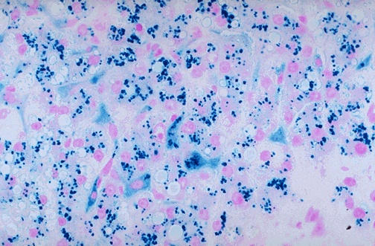
a) H & E
b) Prussian blue iron stain
c) PAS staining
d) silver staiting
e) iodine
11) what kind of liver pathology is seen here?
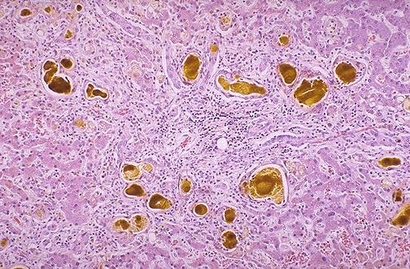
a) multiple liver adenomas
b) carcinoma in situ
c) fatty liver
d) liver cirrohsis
e) cholestasis
e) adenocarcinoma in the lower third of the eosophagus
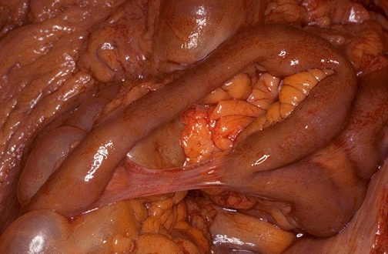
12) 41 year old patient had a surgery to remove part of his bowel , 2 weeks later he comes to the hospital with sign of constipation and X-ray showed intestinal obstruction . This picture represent the patient's bowel what is the cause of intestinal obstruction ?
A- volvulus
B- Adhesions
C- Intussusception
D-Hernia
E-Infarction

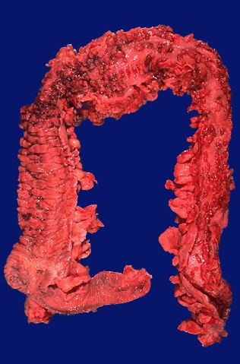
13) in which of the following diseases is this seen?
a) adenocarcinoma of the colon
b) celiac disease
c) crohns diseases
d) Ulcerative colitis
e) carcinoid tumor

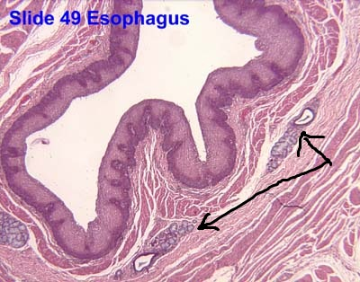
14- The following specimen is a cross section taken in Upper third of the esophagus , The pointed structure represent which of the following ?
- Cardiac glands
- Esophageal gland proper
- Auerbach plexus of nerves
- Muscularis mucosa
- Lamina propria

15- All of the following about The pointed structure in the following picture is correct except :
- They neutralize the acids coming from the stomach
- They are found in the submucosa of the duodenum
- They secret mucous to protect the lining of duodenum
- The esophagus and the duodenum are the only organs in the GI tract with glands in their submucosa
- None of the above
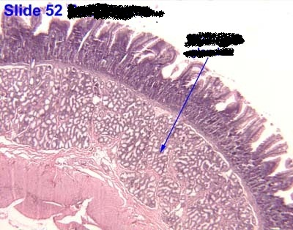

16- The following specimen was taken from the ileum , identify the structure pointed by the arrows :
- Myenteric plexus
- Brunner glands
- Peyer's patches
- Crypts of Lieberkuhn
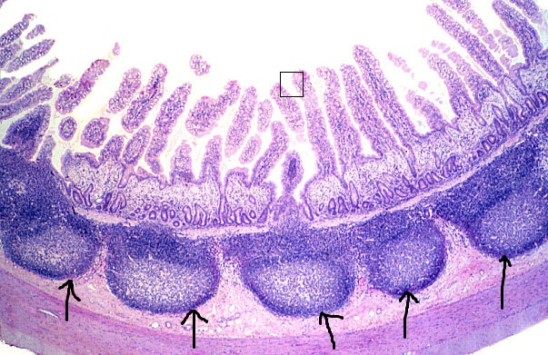
- Blood vessels
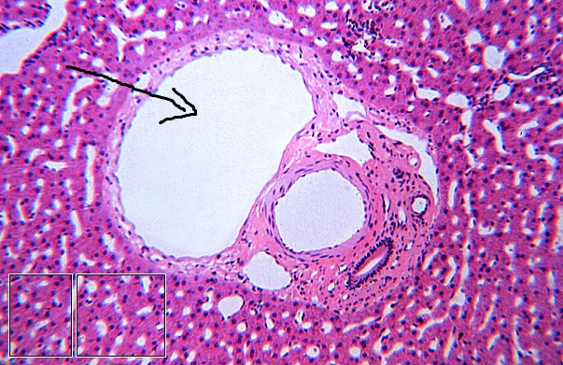
17- Identify the pointed structure
- Hepatic arteriole
- Bile ductule
- Central vein
- Portal venule
- Lymph node

18- Widal test is used to identify which of the following bacterial infections :
- Enteric Salmonella
- Salmonella paratyphi
- Salmonella Typhi
- Shigella
- Brucella
19- Adding Acetylcholine to a section of the small intestines in the laboratory will cause which of the following :
- Increase tonic contraction
- Increase intestinal peristaltic contraction
- Increase intestinal glandular secretion
- All of the above
- More than one of the above
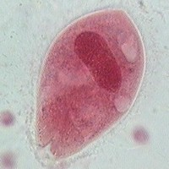
20- all of the following is correct about the micro-organism in the picture except :
- It is considered one of the biggest protozoa
- It has an anterior and posterior opening
- It only reproduce asexually
- It causes bloody diarrhea similar to E-histolytica
- It has an animal reservoir

______________________________________________________________________________
The end

Answers
1-D | 2-D | 3-E | 4-A | 5-D | 6-C | 7-B | 8-C | 9-E | 10-A
11-D | 12-C | 13-A | 14-E | 15-B | 16-B | 17-C | 18-E | 19-E | 20-B
21-B | 22-A | 23-D | 24-C | 25-E | 26-A | 27-B | 28-A | 29-A | 30-B
31-B | 32-D | 33-A | 34-E | 35-A | 36-C | 37-E | 38-E | 39-E | 40-C
41-B | 42-A | 43-E | 44-B | 45-C | 46-A | 47-E | 48-A | 49-D | 50-B
51-A | 52-D | 53-C | 54-C | 55-A | 56-D | 57-C | 58-D | 59-C | 60-A
61-A | 62-E | 63-C | 64-A | 65-B | 66-E | 67-C | 68-E | 69-E | 70-C

Lab answers
1-C | 2-B | 3-B | 4-D | 5-E | 6-E | 7-A | 8-D | 9-C | 10-B
11-D | 12-B | 13-D | 14-B | 15-C | 16-C | 17-D | 18-C | 19-D | 20-C

-Good luck in your exam everyone I hope you all the best .

